# Lab 4.2 Develop the Sales Tax Calculator

In this exercise, you’ll develop an application that calculates the sales tax and invoice total after the user enters the subtotal and tax rate.

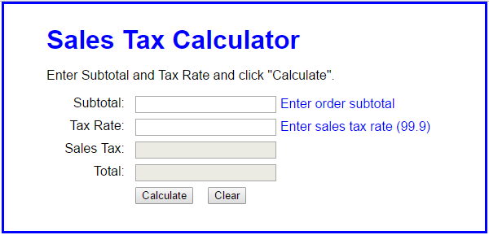

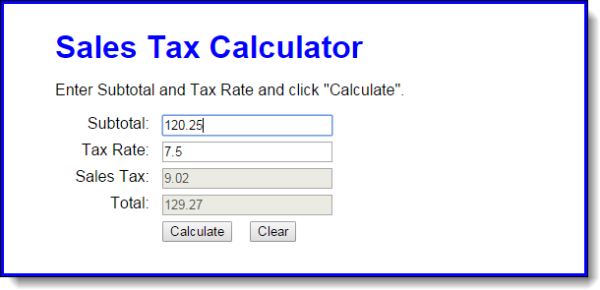

1. Open the HTML and JavaScript files. Then, run the application to see the user interface shown above, although that interface won’t do anything until you develop the JavaScript for it.
2. In the JavaScript file, note that the $ function has been coded for you. It gets the object for the HTML element that’s specified by the id attribute.
3. Code an event handler (function) named processEntries that gets the user entries, calculates the sales tax and total, and displays those results in the text boxes.
4. Code an onload event handler that attaches the processEntries function to the click event of the Calculate button. Then, test what you have so far.
5. Add data validation to the processEntries function. The subtotal entry should be a valid, positive number that’s less than 10,000. The tax rate should be a valid, positive number that’s less than 12. The error messages should be displayed in the span elements to the right of the input text boxes, and the error messages should be:

Must be > 0 and < 10000  
Must be > 0 and < 12

To access the <span> elements (Tax rate example):

$(“tax_rate_message”).firstChild.nodeValue = “Must be > 0 ….”;

1. Add JavaScript that moves the cursor to the Subtotal field when the application starts and when the user clicks on the Calculate button.
2. Add the JavaScript event handler for the click event of the Clear button. This should clear all text boxes, restore the starting messages shown above to the right of the input text boxes, and move the cursor to the Subtotal field.
3. Add JavaScript event handlers for the click events of the Subtotal and Tax Rate text boxes. Each handler should clear the data from the text box.